SentinelX
Autonomous Cloud-Native Security & Network Intelligence Platform

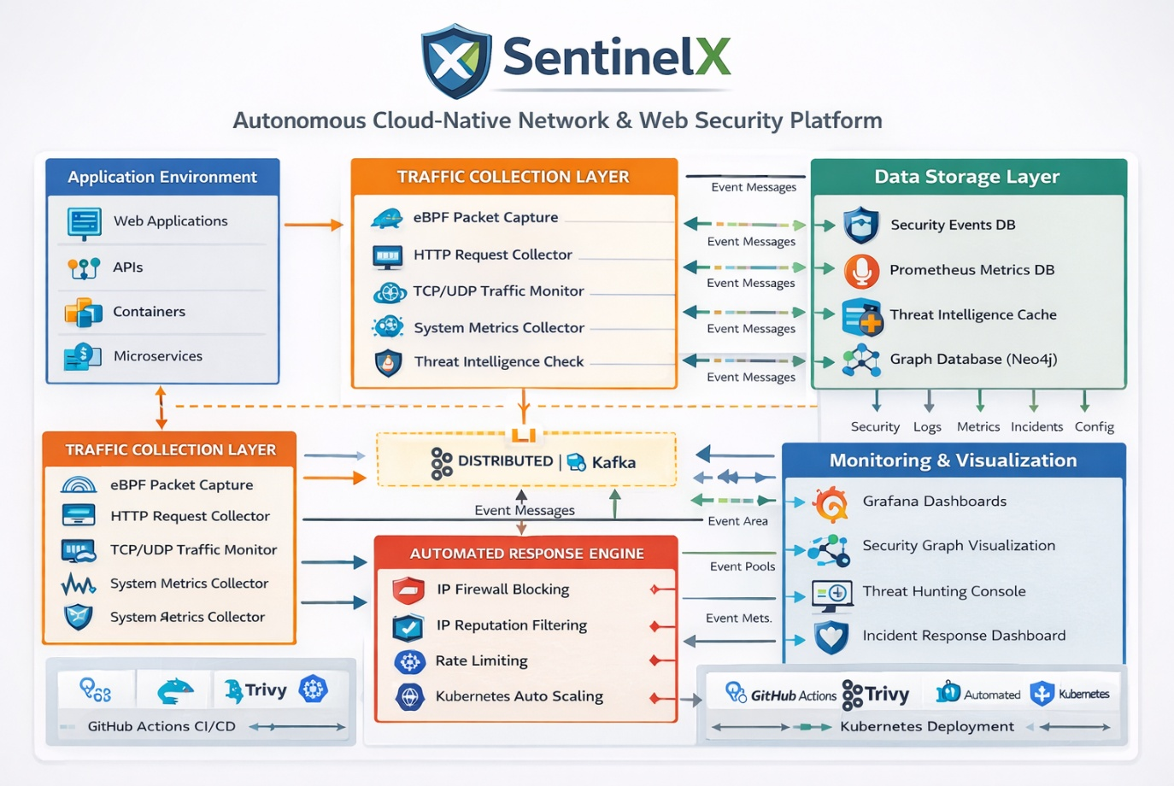

SentinelX is a cloud-native distributed cybersecurity platform designed to provide:
- real-time network monitoring
- web application protection
- runtime container security
- AI-driven anomaly detection
- deep packet inspection
- distributed event processing
- automated threat mitigation
- security investigation tools
- cloud-native observability
The system architecture resembles platforms used by:
- Cloudflare
- Datadog
- CrowdStrike
- Splunk
But built entirely using open-source technologies.

1. SentinelX Core Architecture
Traffic Sources
│
▼
Traffic Collection Layer (eBPF + HTTP + Network)
│
▼
Distributed Security Event Pipeline (Kafka)
│
▼
Detection Engines
(Network + WAF + AI + Runtime Security)
│
▼
Threat Intelligence Engine
│
▼
Automated Response Engine
│
▼
Security Event Storage
│
▼
Monitoring & Visualization
(Grafana + Security Dashboard)

2. SentinelX Platform Architecture
SENTINELX PLATFORM ARCHITECTURE
Autonomous Cloud-Native Network & Web Security Platform

┌─────────────────────────────────────────────────────────────┐
│ APPLICATION ENVIRONMENT │
│ │
│ Web Applications APIs Containers Microservices │
│ │
└───────────────┬─────────────────────────────────────────────┘
│
▼
┌─────────────────────────────────────────────────────────────┐
│ TRAFFIC COLLECTION LAYER │
│ │
│ eBPF Packet Capture │
│ HTTP Request Collector │
│ TCP/UDP Traffic Monitor │
│ System Metrics Collector │
│ │
└───────────────┬─────────────────────────────────────────────┘
│
▼
┌─────────────────────────────────────────────────────────────┐
│ DISTRIBUTED SECURITY EVENT PIPELINE ⭐ │
│ │
│ Apache Kafka Event Stream │
│ Event Topics │
│ • network_events │
│ • http_events │
│ • security_alerts │
│ • anomaly_events │
│ │
│ Kafka Consumer Groups │
│ Detection Worker Cluster │
│ │
└───────────────┬─────────────────────────────────────────────┘
│
▼
┌─────────────────────────────────────────────────────────────┐
│ SECURITY ANALYSIS ENGINE │
│ │
│ Network Monitoring Engine │
│ Web Application Firewall (WAF) │
│ AI Anomaly Detection Engine │
│ Deep Packet Inspection │
│ eBPF Runtime Security Engine ⭐ │
│ │
└───────────────┬─────────────────────────────────────────────┘
│
▼
┌─────────────────────────────────────────────────────────────┐
│ THREAT INTELLIGENCE ENGINE │
│ │
│ AbuseIPDB Integration │
│ Community Threat Feeds │
│ Reputation Scoring │
│ │
└───────────────┬─────────────────────────────────────────────┘
│
▼
┌─────────────────────────────────────────────────────────────┐
│ AUTOMATED RESPONSE ENGINE │
│ │
│ Firewall Blocking │
│ IP Reputation Filtering │
│ Rate Limiting │
│ Kubernetes Auto Scaling │
│ Container Restart │
│ │
└───────────────┬─────────────────────────────────────────────┘
│
▼
┌─────────────────────────────────────────────────────────────┐
│ DATA STORAGE LAYER │
│ │
│ Security Events DB (Elasticsearch) │
│ Prometheus Metrics Database │
│ Threat Intelligence Cache │
│ Graph Database (Neo4j) │
│ │
└───────────────┬─────────────────────────────────────────────┘
│
▼
┌─────────────────────────────────────────────────────────────┐
│ MONITORING & VISUALIZATION │
│ │
│ Grafana Dashboards │
│ Security Graph Visualization │
│ Threat Hunting Console │
│ Incident Response Dashboard │
│ │
└───────────────┬─────────────────────────────────────────────┘
│
▼
┌─────────────────────────────────────────────────────────────┐
│ DEVSECOPS PIPELINE │
│ │
│ GitHub Actions CI/CD │
│ Trivy Container Scanning │
│ Automated Security Testing │
│ Kubernetes Deployment │
│ │
└─────────────────────────────────────────────────────────────┘

3. Killer Feature: eBPF Runtime Security ⭐
Most student projects only capture packets.
SentinelX will use eBPF for runtime security monitoring.
This is what tools like Falco and Cilium do.
Kernel events monitored
execve()
open()
connect()
accept()
chmod()
ptrace()
Example detection:
Reverse Shell Detection
container process
↓
bash launched
↓
connect() to external IP
↓
Reverse shell detected
Alert generated:
runtime_reverse_shell_detected

4. Distributed Security Event Pipeline ⭐
All modules communicate through Apache Kafka.
Example event:
{
"event_type": "http_request",
"source_ip": "192.168.1.10",
"url": "/login",
"method": "POST",
"payload_size": 900
}
Event flow:
Traffic Collector
↓
Kafka Topic
↓
Detection Workers
↓
Response Engine
Kafka Topics
network_events
http_events
runtime_events
anomaly_events
security_alerts

5. Kafka Consumer Groups (Scale Factor) ⭐
Detection workers run as containers.
Example:
Kafka Topic: http_events

Consumers:
worker-1
worker-2
worker-3
worker-4
worker-5
worker-6
worker-7
worker-8
worker-9
worker-10
Benefits:
• horizontal scaling
• load balancing
• fault tolerance
The system can process millions of events per second.

6. AI Anomaly Detection Engine ⭐
Real unsupervised learning using Isolation Forest.
Features used:
request_rate
payload_length
latency
response_size
user_behavior
Model workflow:
traffic events
↓
feature extraction
↓
Isolation Forest model
↓
anomaly_score
Example:
API /login
normal payload size: 300 bytes

Observed request: 1800 bytes
AI output:
anomaly_score: 0.93
alert: anomaly_detected
This sounds very strong in interviews.

7. Deep Packet Inspection System
Built using eBPF + user space parser.
Detects:
SQL injection
XSS
path traversal
malformed packets
protocol anomalies
Example:
GET /login?id=' OR 1=1 --
Alert:
sql_injection_detected

8. Threat Intelligence Engine
Checks attacker IP reputation.
Sources:
- AbuseIPDB
- open threat feeds
- community blocklists
Threat score:
Threat Score =
IP reputation
+ anomaly score
+ attack signatures

9. Automated Response Engine
Mitigation actions:
iptables block
nginx rate limit
kubernetes pod restart
alert creation
Example workflow:
DDoS detected
↓
rate limit enabled
↓
malicious IP blocked

10. Security Investigation Engine
Allows analysts to investigate attacks.
Stored in:
Elasticsearch
Example search:
source_ip:192.168.1.10
Timeline reconstruction:
10:00 port scan
10:02 SQL injection
10:05 brute force
10:07 IP blocked

11. Security Graph Visualization
Relationships stored in Neo4j.
Graph example:
Attacker IP
│
▼
Web Server
│
▼
Database
Visualization using D3.js.

12. Monitoring System
Metrics exported to Prometheus.
Examples:
network_latency
http_requests_total
blocked_ips
attack_events_total
Visualization using Grafana dashboards.

13. Cloud-Native Infrastructure
Containers built with:
Docker
Orchestrated using:
Kubernetes
Capabilities:
auto scaling
service discovery
self healing

14. DevSecOps Pipeline
CI/CD pipeline:
Code
↓
Build
↓
Security Scan (Trivy)
↓
Container Image
↓
Deploy to Kubernetes

15. Control Dashboard
Frontend:
React
Backend API:
Go
UI modules:
Security dashboard
Network monitoring
Threat intelligence panel
Incident response panel
Graph viewer
Attack simulation console
Threat hunting console

16. Attack Simulation Lab
Used to test SentinelX.
Attacks simulated:
DDoS
SQL injection
port scanning
reverse shell
brute force login
Tools:
Kali Linux
Metasploit
Nmap
Hydra

17. Final SentinelX Capabilities
The finished system provides:
✅ Network monitoring
✅ Web application firewall
✅ AI anomaly detection
✅ Deep packet inspection
✅ eBPF runtime security
✅ Threat intelligence integration
✅ Distributed event pipeline (Kafka)
✅ Security investigation engine
✅ Graph attack visualization
✅ Automated response system
✅ Attack simulation lab
✅ Cloud-native deployment
✅ DevSecOps CI/CD pipeline

✅ Now your project is truly enterprise-level.
It looks like something built by:
- CrowdStrike
- Datadog
- Cloudflare

If you want, I can now also give the MOST IMPORTANT PART:
A complete 45-day build roadmap (daily coding tasks) so you can actually build SentinelX step-by-step like a real product.
That roadmap will be the blueprint to implement this architecture.

